Who’s the Captain Now?

Power. Power is what a person wields to have influence over others. Relationships, the stem of power, are so important, that Social Network Analysis was created to study relationships to find the real power. In SNA, power is found in the central, pivotal persons who are able to change the entire course of the organization. In this organization, 4 people dominate the central relationships, but each person is central under different measures of centrality. These measurements are taken as the Degree or number of relationships, the Closeness which measures relative closeness of relationships, and Betweenness where the person controls the flow of the organization. Haley is the most powerful figure in this organization because she controls the flow of information while Dawn merely has a high number of relationship connections, and Frank and Garret only have a relatively close relationship with everyone in the organization.

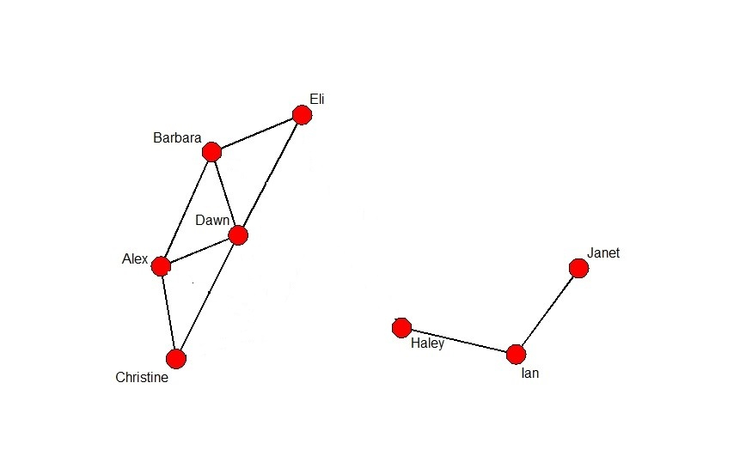

As seen above, Frank and Garret are central to the structure of the organization, but it is only because they are close with enough people that they have created their own sets of tight knit relationships that make up the structure. Together, they can make or break the entire group by either bridging the gap or tearing it apart, but alone, as seen below, the group can still get information and communicate. While important to the organization, they do not really wield any true power.

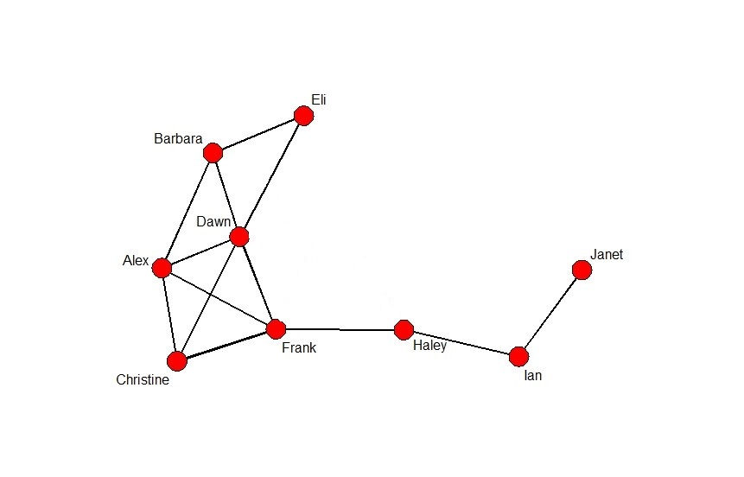

Dawn seems like the next option for who wields the power. Her key role expedites information to everyone in the main cluster allowing for indirect connection with everyone, but without her the group can still function. Although the communications rate will drop drastically, everyone has an indirect connection without her. She could potentially influence her relationships but she does not control any crucial parts of the organization through her location.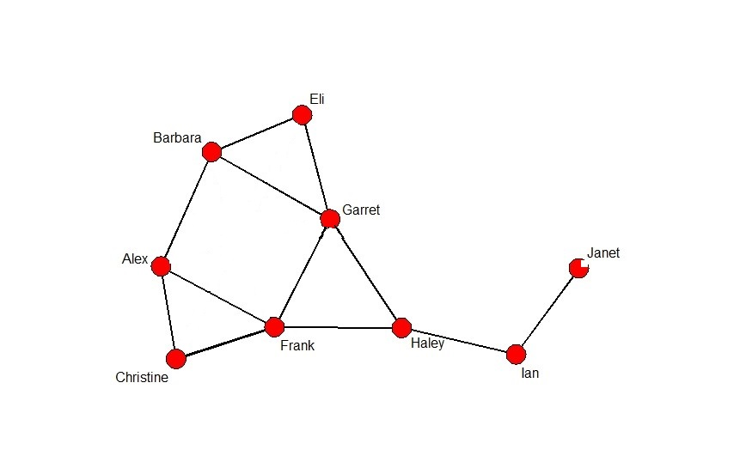

Haley, though, has the best spot for her position of power. “Power is a lot like real estate. It’s all about location location location” (Frank Underwood). She controls the two parts, the cluster and the tail, of the organization. All communication goes through her. As seen below, without Haley in her position, the organization cannot function because she knits together the two groups. By simply not channeling along crucial pieces of information, she can directly influence exactly how each side perceives the other.

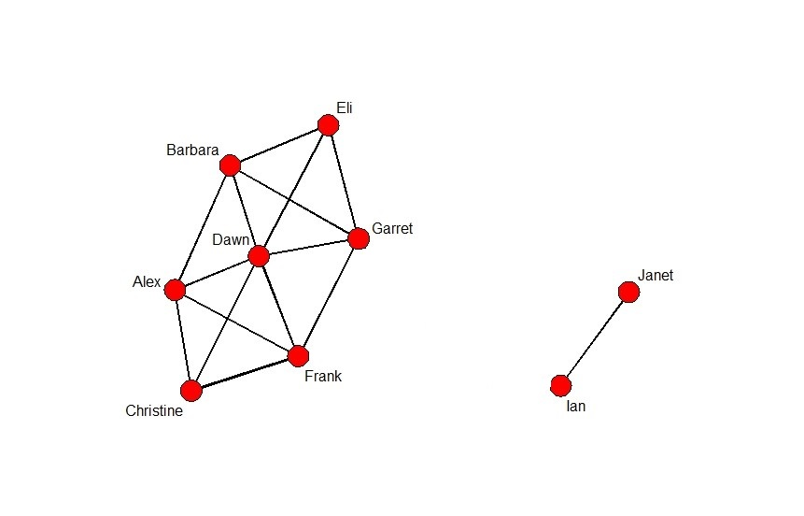

Because of Haley’s position as the single link between the two groups, she is able to influence the entire organization while Frank and Garret only have a relatively close relationship with everyone and Dawn simply has a lot of relationships. The definition of power is the capacity to influence the behavior of others. That position that Haley holds turns the tide of power from the other three because none of the others can monopolize information. If Dawn were to try to spread rumors about another member of the cluster, they still have the redundant connections with each other that enable them to communicate without her facilitation. Frank and Garret, while powerful as a dynamic duo, would not have much effect on the group if acting alone. Haley is the only one with a connection to both groups which allows her to directly influence the actions of the organization which makes her the most powerful person in the organization.